Karen’s Kounsel
February 2012 Page 1 of 2

KLynn Counseling
a place for new beginnings

There is no more lovely, friendly, and charming relationship, communion, or company than a good marriage.
Martin Luther

Marriage is an exercise in torture.
Frances Conroy

Two people with extremely divergent views on marriage! Which one is right? I have learned from my own experience and from the many people I have worked with over the years that the answer to that question can be either one – or anywhere on the scale in between. It would be impossible to give solutions to all the problems that married couples face in one short newsletter, or even in one book. But wherever you are on the continuum from torture to bliss, there are always steps you can take to move up the scale. In the next several newsletters I’d like to take a look at a few well researched psychological principles that contribute to a happy marriage (OK guys; don’t roll your eyes at the prospect of “psycho babble”. I promise it will be to the point and understandable), then we can look at how that compares with scripture, and a little bit of Karen’s kommon sense.

A good marriage doesn’t just happen. It takes some effort, actually a great deal of effort. Is it worth it? Well, just to give you a little motivation, latest research shows that people in an unhappy marriage have a significantly higher chance of getting sick and have a shorter life span. While in some cases, such as unrepentant infidelity or abuse, a partner may be left with little choice, divorce is not the easy answer. Research has shown that the stress connected with divorce can lower the immune system’s ability to fight off physical illness. The good news is that in happy marriages people have less physical illness, longer life spans on average, and even an increase in the white blood cells which are the immune system’s chief defense weapon, and we want to keep those little warriors as high as we possibly can! So let’s start with a few major principles that might edge you up that happiness scale a few notches.

Increase you marital IQ
Research has shown that intimately knowing your spouse plays a vital role in a happy long lasting marriage. It can even help hold you together when having to deal with difficult events. Do you know the answer to questions such as: What are my spouse’s deeply held religious beliefs? What is his/her philosophy of life? Who does he/she think of as closest friends? What were some of my spouse’s favorite memories as a child? The most traumatic memories? What is my spouse most concerned about right now? Who is my spouse’s least/most favorite family member and why?

Does scripture agree with this research finding? In 1 Peter 3:7 the King James Version admonishes husbands to “dwell with your wives according to knowledge”. The Message renders that verse as “delight in them”, and both versions say that this is so your prayers won’t be “hindered” or “run aground”. I can’t think of a better way to delight in someone than to want to know all about them. Nothing connects you with someone more than when you believe that they are truly interested in you – how you feel, what you think. It creates a bond that goes deeper than the surface and it is more satisfying than just a physical relationship. Knowing your spouse in a more in-depth way might give you a better perspective on some of those things they do that so annoy you and can help you work them out together. (More on this in next month’s edition) Try spending a little time with your spouse and ask them a couple heart to heart questions that you might not have the answers to. What they feel might surprise you – and give you more insight than you expected.

Remember when. . .
No matter how high your level of aggravation might be with your spouse at the moment, there were some good times, some fond memories. After all you did marry them! Something caught your eye to begin with, right? Studies show that thinking back over and remembering these special moments, events, and feelings builds up a positive account that keeps the disagreements and angry moments in perspective. Scripture certainly agrees with this concept. Philippians 4:8 says, Finally, brethren, whatsoever things are true, whatsoever things are honest, whatsoever things are just, whatsoever things are pure, whatsoever things are lovely, whatsoever things are of good report; if there be any virtue, and if there be any praise, think on these things. A particularly good time to try this might be on birthdays or anniversaries (unless you forget those important dates, which is a whole other subject!). My husband and I sit down on our wedding anniversary and go over our wedding album and our honeymoon pictures and we remember some of the sentimental things that happened when we were dating. We laugh over the funny events that may have seemed aggravating at the time because time has a great way of giving you perspective.

Consult – don’t just barge ahead!
Long term studies have shown that the most stable marriages are those in which both husband and wife treat each other with respect and consult with each other over significant decisions. This doesn’t mean that you give up the right to be your own person, but considering your spouse’s point of view lessens negative attitudes. In my lifetime (which is longer than I will admit to here) I have heard numerous sermons preached, and read just as many books on the subject of wives submitting to their husbands. Scripturally speaking, our previous verse in 1 Peter 3 says that husbands should “treat their wives with respect” and in Ephesians 5:33 it states that “the wife must respect her husband.” The 1 Peter text also holds up Sarah as a model for wives. With that in mind, I will just say that Sarah was no shrinking violet. Look up Genesis chapter 21 and read about the disagreement that Abraham and Sarah had. First – Abraham listened to her, even though he didn’t like what she was saying. Second – he took it to the Lord (a sign of respect). Third – The Lord agreed with Sarah and told Abraham “in all that Sarah hath said unto thee, hearken unto her voice”. This is not to say that only men need to hear this. I have seen many women who need to give thought to their husband’s opinions and feelings on a matter. The Bible talks about mutual respect.

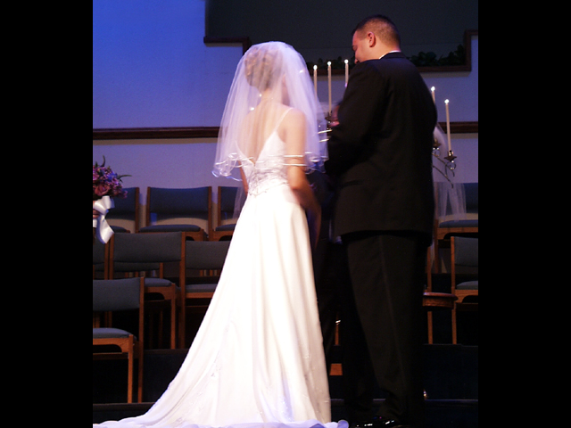

These three ideas are just a starting point and are described here in a very brief summary. No matter where your marital relationship stands at this moment, anything you do to make a move in a positive direction will make a difference. It changes the momentum. Sometimes we get caught in a cycle of behavior, and one or two little disruptions in that cycle can open your eyes to a new adventure. And that is what marriage should be, two people on trip of discovery and adventure. And don’t be discouraged just because the waters get a little rough now and then. We know the One who walks on water and calms the storms!

