Karen’s Kounsel
February 2013 Page 1 of 2

KLynn Counseling
a place for new beginnings

Your wealth is where your friends are.
- Plautus
Connections. They are so important. In our high tech society we appear to be more connected than ever. Many of us cannot go anywhere without a cell phone. Those cell phones can connect us to the internet and anything or anyone at any time. And yet we seem more isolated than ever. People who have spent inordinate amounts of time “communicating” on the internet go out leaving a parting post or twitter message and then commit some unthinkable crime before ending their own life. Research shows us that those with close personal relationships, with a social network as a resource, are physically healthier, have better mental health, and live longer. People who isolate themselves have higher rates of depression, anxiety, and illness. Spending time with friends actually raises the immune levels. Another benefit to being a part of a community of supportive connections is the contribution that you can make. While others can be a great advantage to you, it is also true that you have unique gifts and talents that are a help to those you associate with.

Recently I spent three days on a retreat where there were no laptops, no cell phones, no outside communication. At first it was unsettling and uncomfortable. But without these tools of modern communication, I ended up with some very close relationships with a group of people that I had never met before. I heard their thoughts, their deeply held beliefs, their faults and failures, and also their faith and their triumphs. I was also able to spend close and personal time with God. I had the opportunity to examine my heart and let the Lord show me some surprising attitudes lurking there. My husband and I resolved some issues which brought us closer together. We were created for connection and relationship. Without it we flounder and become less than we could be. Let’s look at some ways that we can build and enhance the relationships in our lives.

- Start with yourself. Scripture tells us to “love your neighbor as yourself” (Mark 12:31). The concept of this is that if you can’t accept yourself, you will have trouble accepting others. Look at yourself realistically. You have been created wondrously. Explore those areas and give yourself credit. Major on those areas and expand them. If you have a talent for writing start writing, even if it’s a journal that only you read for now. Write a note of encouragement to someone. If you are good at sports, join a team or take walks. When you look at those areas that make you feel bad about yourself, start working on them and applaud every bit of success. We all have issues that we wish we didn’t. That just makes you human. But start somewhere to make changes that you would like to see. Get help if necessary. To ask for help is a sign of maturity not weakness.
- Let people be what they can be. As you start to accept yourself, you will be able to be more accepting of others. Look at the people in your life as realistically as you do yourself. If someone if great fun to go shopping with, but you can’t trust them with your confidences, then shop with them, have a good time, and tell your secrets to someone else. That way there is less to be offended by and less to forgive.
- Live gracefully. When you can accept people for who they are then you are able to extend grace to them just as God extends grace to us. It is strength to overlook a cutting remark or a foolish act, to extend a complement when someone is insulting. “It is to one’s glory to overlook an offense” Proverbs 19: 11. Realize that we never know what goes on behind closed doors or what is in another person’s past that causes them to react the way that they do. Give them the benefit of the doubt if possible.
- But set your boundaries. Of course, that does not mean that you let people walk all over you. You can set boundaries and still be gracious. If someone can’t be trusted, take note of that and be sure not to entrust them with anything you can’t afford to lose. Just because you smile and are gracious when someone is less than gracious does not mean that you must continually put yourself in the way of their steamroller!
- And forgive freely. But when they do offend or insult you let it go. Forgiving does not mean that what they did is OK or it is in anyway acceptable. It just means that you don’t hold onto it and let it fester inside of you. When you let it go you give it to God. You can trust him to deal with it in perfect mercy and justice. We are not always so good at drawing those lines.
- Accept that love will hurt. Realize that when you attempt to build strong lasting relationships, you will get hurt. Even the best people are human and fallible. They will have bad days and be cranky. They will have baggage from their past that will cause them to act in ways you may not understand or approve of. You may make an error in judgment about a person who ends up seriously taking advantage of you or hurting you. Unfortunately, that is a part of this world we live in. It is not a reason to shut yourself away or become untrusting of everyone. You just dust yourself off, give yourself some time for reflection and healing, learn from it, and be courageous enough to try again.
- Start somewhere. With all of this in mind, just begin. Invite someone over. Sit down and really have a heart to heart talk with someone you’ve neglected in the chaos of life. Speak a kind word to someone who is down. Visit that elderly neighbor who is lonely. And don’t neglect building your relationship with God. Give Him some time out of that hectic day. You don’t even need to text Him. He is as close as the thoughts that you think, and He is the one friend who will never betray you or let you down.
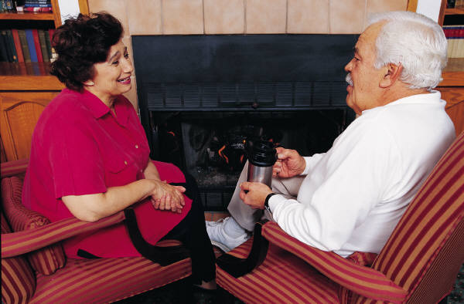
Before they call I will answer; while they are still speaking I will hear. Isaiah 65:24

