Karen’s Kounsel
April 2013 Page 1 of 2

KLynn Counseling
a place for new beginnings

I will praise thee; for I am fearfully and wonderfully made: marvelous are thy works; and that my soul knoweth right well. Psalm 139:14
We are simply amazing. We are made up of cells and DNA that is intricately woven together to create organs, blood, and muscles. .Each one of us is unique. No one has the same fingerprints. Hair color and texture, eye color, skin tone, combine to give you a look that is your own. Besides that, the mass of grey matter that is up in your head has uncountable neurons and pathways and chemicals that give you the ability to see, and to feel. You are able to work through a math problem and also to ponder complex philosophical questions. In this mind and body complexity is a spirit that enables you to love, to hate, and to connect with the Creator of it all.
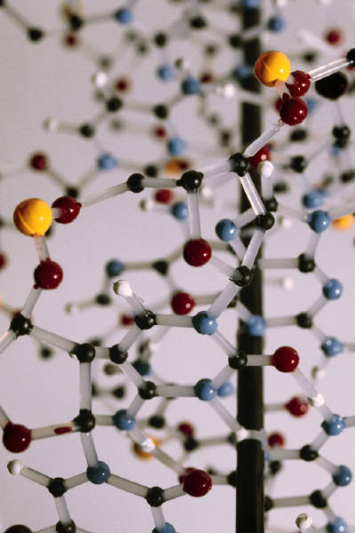
Science has come to think that they know and understand this intricacy, and in some small measure they do. But when they begin to try to alter DNA in even simple plants to “enhance” them, they end up changing parts of the plant that they didn’t realize were connected to what they were doing. That just goes to show that when God made us He had a map and a plan that fit together in many ways we cannot begin to understand and unwind. We need to realize that if we want to be whole, healthy people.
Let’s look at a few ways that our mind, body, and spirit are connected. The scriptures tell us that “A merry heart doeth good like a medicine: but a broken spirit drieth the bones”. Proverbs 17:22. Interestingly, research has shown this to be true. At a successful cancer treatment center one of the treatments they provide is “Laughter Therapy”. This is why: “Research tells us that laughter stimulates the body to produce its own antidepressant - a natural painkiller. Laughter is also a wonderful stress reliever and a great relationship builder. It may stimulate your immune system to aid in the healing process. It also facilitates learning and helps your body generate energy”. Cancer Treatment Centers of America
Research also shows the benefit of exercise. We all know that exercise is good for the heart, for losing weight, and for a variety of other bodily health issues. But exercise also has a great effect on your state of mind. It releases chemical reactions in the brain that can be as good as medication for depression (without some of those inconvenient side effects).
In the matter of health it has also been found that your spiritual life can change your health. A study was done comparing people who had been hospitalized or had surgery. Those who had prayer or prayed themselves had a much more successful and higher rate of recovery. Scripture tells to, “attend to my words; incline thine ear unto my sayings. Let them not depart from thine eyes; keep them in the midst of thine heart. For they are life unto those that find them, and health to all their flesh”. Proverbs 4:20-22.
So today I’m going to just offer a few tips on helping take care of the whole person.
Give priority to taking care of your physical health. Start with healthy eating. We are a nation of fast food and convenience, which tends to wreak havoc on our bodies. Changing some of those habits may come easier if you begin a little at a time. Cut back on sugar instead of trying to get rid of it altogether. Add some fruits vegetables here and there. Try more natural foods rather than processed. Make changes that you like and you will be more apt to stick with them.
Find an exercise program that works for you. Even a short walk every day will begin to make a difference. It will give both your body and your mind a boost. It will help boost your energy level and your confidence.
Take care of your emotional health. See that you get some mental relaxation. Find a quiet place and time that is all yours. Play your favorite music and let it “soothe the soul” as that classic rock song says. Read an enjoyable book. Sit on the back porch and appreciate the beauty of a tree or the flowers. Watch a ballgame with your friends. Enjoy a cup of tea and conversation with your best friend (you know who you are). If the problems that cause you distress need more serious attention, invest in some counseling. You would be amazed how much difference an objective listening ear can make.
Feed your spirit. Prayer not only changes circumstances, it changes you. Take the time to have some communion with your Creator. Spend a few moments each day in His Word. It provides a strength and peace that can carry you through.
Live your life with the realization that you were created as a whole person. All of the pieces that fit together to make you who you are have meaning. A little exercise after a tough day might just clear your mind and help you make the best decision in a complex situation. This could lead to a successful outcome or keep you out of harm’s way. A. habit of relaxation might lower your blood pressure and keep you here with us on the planet for a few, or even many, more years,
You can never tell how one thing will lead to another. We never see the whole picture at the time we do something. It always amazes me how one thing connects to another and then leads to something else, and then affects a part of your life way out in left field. Your good decisions can end up making incredible differences. With that in mind, I leave you this month with this prayer:
May God himself, the God of peace, sanctify you through and through. May your whole spirit, soul and body be kept blameless at the coming of our Lord Jesus Christ. 1 Thessalonians 5:23

