Karen’s Kounsel
May 2013 Page 1 of 2



KLynn Counseling
a place for new beginnings

Making the decision to have a child is momentous. It is to decide forever to have your heart go walking around outside your body. ~Elizabeth Stone



We just celebrated Mother’s Day. That day can evoke a flood of memories – memories of all kinds. If you are a mother, this month’s newsletter is dedicated to you. Moms come in all forms. Some are biological mothers, some are adoptive mothers and some are foster mothers. Some of you are moms to the world. Kids just seem to gravitate to you. You might have kids of your own, but the rest of the neighborhood shows up at your door looking for a cookie, a little advice, or just a feeling of home. Whichever description fits you, you take on a momentous task when you choose to influence the life of a child. You are a blessing.

And that job seems to be harder than ever. Temptations and dangers pop up at every turn. Predators have honed their “craft” to a science. The days of “Father Knows Best”, “Leave it to Beaver”, and ol’ Andy back in Mayberry with his ever sensible down home advice have vanished like a puff of smoke. Some of you may not even know to whom I am referring (I have probably just given a big hint to my age), but even my daughters grew up watching those old reruns. Where in the world do mothers today draw the boundary lines? When you hear “everybody is doing it” or “everyone is wearing this” how do you hold your ground? What if you make a mistake? What if you entrust your precious child to the wrong caregiver? Will you damage them for life?

Just remember that mothers down through the ages have also lived through, and raised children, in difficult and heartbreaking times. In the years following Jesus resurrection, those who professed the faith were jailed, burned at the stake and tortured. In the dark ages, disease took newborns, toddlers and mothers. In civil war days, some mothers endured their children fighting each other on different sides of a bloody war. Every generation has had their trials and tribulations when raising its children. The Lord, who was faithful to them, will be faithful to you too.

And what about those mistakes? We all make them. Even the family you see at church or school that appears “picture perfect” is not. We all bring baggage from our own growing up time. We’ve all said things like “when I have kids I’m never going to do that” and then we either find ourselves doing exactly that, or something else just as bad. So we are human. Kids are resilient. More important than being perfect (which is good since none of us are), is being genuine. When you make a mistake, say so. It goes something like this: “I’m really sorry. I wish I hadn’t done that. Can you forgive me? I’m really going to try to change that”. Believe me; they know you were wrong anyway. An honest apology will cut out resentment, it will build real trust, and it will engender their respect. Some of the most healing times I have seen in a family are when there is sincere repentance and forgiveness.

If you have ever read Proverbs 31, you get a picture of an ideal wife and a mother. It’s a high standard to live up to. King Solomon was talking about his mother in this chapter. Some of the accolades are as follows:
- She’s doesn’t get much sleep since she’s up taking care of the duties of a household while it is still dark (v. 15).
- She keeps herself in good physical shape (v. 17).
- She is a successful business woman, at times working late into the night (v. 16, 18, &24).
- She is involved in the community and provides for the poor (v. 20).
- She pulls all this off and still manages to be a snappy dresser (v. 22).
- She is a great household manager (v. 13-15, 21).
- She gives wise advice (v. 26).
- And to top it all off, she is a woman of great faith (v. 30).
Sounds impossible, doesn’t it? Well, when contemplating all of this, just remember who Solomon’s mom was. Bathsheba. Her relationship with Solomon’s father, King David himself, had a very tumultuous and adulterous beginning. Perfection was not in the background of this family. Yet the overwhelming grace of God brought something amazing from all of this sorrow and sin. What a hope to hold onto!
Bathsheba, like the rest of us, was a mother who loved her son. She loved him just like you love your kids. While there was much that could have really scarred Solomon for life, somehow her love for him won out and it obviously did a work in her own life as well. It doesn’t matter if your children are infants or grown adults. Mom is always going to be mom. And that may be the most important thing of all because “Above all, love each other deeply, because love covers over a multitude of sins.” 1 Peter 4:8.
Let whatever you do come from love. When you get up in the middle of the night to take care of a sick child let it be directed by love. When you drive them to the twenty different places, they need to be at the most inconvenient times, love them. When they hit the winning home run cheer them on with love. When they fail a class or get in with the wrong crowd at school, love them through it. When you are angry because they have left the chores undone again, give out those consequences with love. When you reward them or draw the boundary lines where they don’t want them to be, love them. And when you just don’t have the faintest idea what to do, you still love them and you pray, because God is faithful. And God is a parent to us all and His love is perfect.
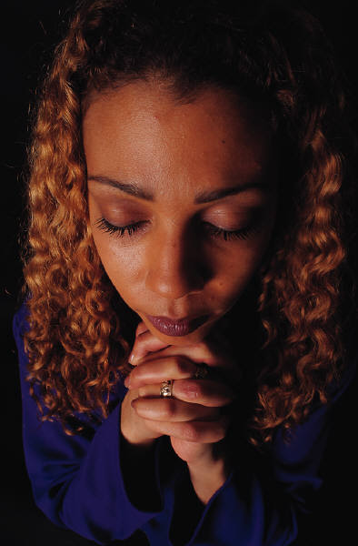
I remember my mother's prayers and they have always followed me. They have clung to me all my life. ~Abraham Lincoln

