Karen’s Kounsel
August 2013 Page 1 of 2

KLynn Counseling
a place for new beginnings

For which of you, intending to build a tower, sitteth not down first, and counteth the cost, whether he have sufficient to finish it? Luke 14:28
Today we’re going to look at a little counsel for those who are preparing to get married. If you planning a wedding, you are certainly starting to “count the cost”. You may be spending hours poring over bride magazines, going to bridal shops, looking at dresses, caterers, churches, reception halls, cakes, and so many other details. That one day is supposed to be perfect. In all of this frantic (and it does get frantic) preparation, how much time have you taken to prepare for the marriage itself? In this month’s newsletter I’d like to take a brief look at some of the issues that you should consider before you take that walk down the aisle. You may want to elaborate on these with your pastor or a counselor who can help you examine them in more depth. The wedding, after all, is only one day out of a lifetime of days that you want to be joyful and filled with love.
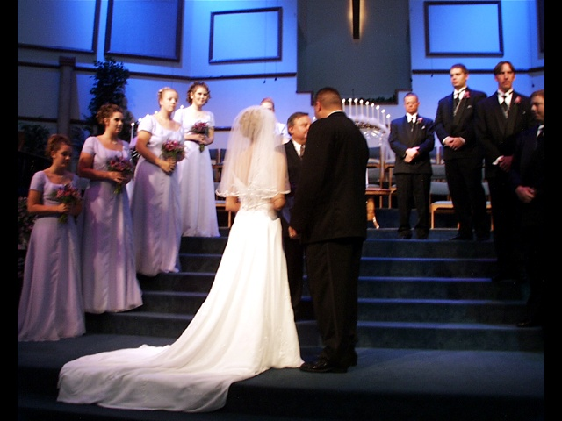
- Communication. If you are going to spend the rest of your life with someone, that person should be your best friend. They should be someone you would trust your heart to and someone you can confide in with the assurance that they will listen and understand – and you want to be that kind of person for them. Communication is more than a surface conversation. Communication should convey your feelings, the parts of your life that are important, your dreams, your hurts, your aspirations. Do you know these things about your intended spouse? Take the time to find out. Make the effort. Not good at delving into some of those areas? Seek the help of someone you trust such as your pastor or a counselor.
- Religious beliefs. This is an important topic to discuss before you get married. Are you and your fiancé in agreement about this deeply personal subject? Sometimes in the beginning of a relationship this gets pushed to the side because the thrill of new love overrides it. Make no mistake, though, in time it will come to the forefront. This can be especially true when children begin to appear. On the other side, when you share a faith, it can be one of the most amazing experiences you can have. You can pray together, worship together, and find wholeness from the past wounds and traumas.
- Finances. In planning your wedding, don’t forget that there is life after the big day. Don’t get into so much debt over this that you are struggling for years after. When examining your finances, you should start putting together a budget. When doing so, be realistic. There are some things that you may be able to afford right away and some that may have to wait while you work up to them. Talk about your jobs, dreams of further education and possible career aspirations. It will be important to be joined together and supportive of each other.
Money may be an inanimate object, but we attach great emotional significance to it. Money only becomes our friend if we as a couple learn to partner around the decisions related to money. One of the prerequisites for partnering in the matter of money is an understanding of the meaning of money to each of us.
Dr David Stoop and Dr Jan Stoop, from the book, “The Complete Marriage Book”

- Kids. Discuss beforehand if you both want children, how many, and what your child rearing beliefs are. Do you agree on these or are you worlds apart? If your intended spouse already has children, how will you adapt as a step parent? This is another issue where you may want to have some objective input. These questions may take some time to work through, but it will be time well spent.
- Family. So many jokes are made about in-laws. Sometimes they are a bit overdone, but sadly some of them are painfully accurate. Remember just a couple of basics. You will probably always love your own parents/family more than your spouse does and vice versa. That is natural. Work at respecting and getting to know your new family, and remember that when you get married, you become a new family. You can value the input of your parents but they should not over shadow the value you place on your spouse’s opinions and feelings.
- Non-negotiables. Decide now what issues in your life are those which you cannot live with or cannot live without. When the day to day routine of life sets in, what are the deeply rooted ideals, beliefs, or dreams that you will truly not be able to compromise on? For everyone, one of those issues should be drug or alcohol abuse. Don’t underestimate the damage that a substance dependency can cause. Without competent professional help it is not likely that it will just “go away” or get better on its own. This is an area that needs the aid of a good counselor. There can be a variety of other areas that you feel are firm and unmovable for you. Work out those areas before they become a source of constant friction.
Marriage can be one of the most wonderful, enriching experiences of your life, or it can be one of the most difficult. Choose carefully with whom you decide to spend the rest of your life. Don’t assume that if it doesn’t “work out” a divorce is a simple procedure. It is heartbreaking and wrenching. It damages both parties and any children that may be a part of it. It is possible to have love for a lifetime, but that outcome takes work from both partners. It is worth any effort you put into it, and in the long term it is actually the easier route. Working through these different areas takes good communication, love, grace, and compromise; but in doing this you will build a relationship and a bond that will hold through the trials and difficulties that life brings to us all. It can teach us how to mature and develop a selfless attitude. It is meant to bring enduring joy, great contentment, and true satisfaction.
“God created marriage. No government subcommittee envisioned it. No social organization developed it. Marriage was conceived and born in the mind of God.” Max Lucado

