Karen’s Kounsel
December 2012 Page 1 of 2

KLynn Counseling
a place for new beginnings

“Do you remember the things you were worrying about a year ago? How did they work out? Didn't you waste a lot of fruitless energy on account of most of them? Didn't most of them turn out all right after all?”
Dale Carnegie

And what about those Christmas gifts that you ran up a debt for? How many people can remember what they got last year for Christmas or the year before? Now I’m not Scrooge, and I’m not saying we shouldn’t give gifts at Christmas. One of my greatest joys is to pick out the right gift for the right person and see their face light up. I hope it lights up because they know that I put thought and care into the present. But when I look at the news stories of Black Friday sales, of people camping out for days, of people bringing knives and threatening other shoppers, of the rushing and the grabbing and the trampling. . .

It was somewhat the same on that first Christmas. There were taxes being levied. Sound familiar? People were rushing around, traveling long distances. There was crowding and pushing and shoving and dashing to get accommodations. Did Bethlehem look like one of our modern day shopping malls or discount stores? Who had time to even notice the man and the pregnant woman? How many expectant mothers were there wandering the streets of Bethlehem anyway? After all, babies don’t know anything about kings or decrees or taxes. Babies come when they want to come. Planning and due dates, deadlines and the orders of kings are not in their date books – only in ours. So in all the frantic pushing and shoving, everyone but a few shepherds missed the greatest occurrence that was to ever take place in history. God Almighty, the Creator of the entire universe, became one of us. Simply put, he set aside all the glory of heaven and was born in a feeding trough with the animals and the manure because it was the only place humankind could spare.

Most of us love the Christmas season and we have visions of it being a time of warmth and family and peace. But so many times it becomes hectic and frazzled. Our schedules become more and more booked until we feel a little like Henry Kissinger in the middle of national and world turmoil who said, “There cannot be a stressful crisis next week. My schedule is already full”. This joyous season can end up leaving us feel empty and depressed.

I know that it is unrealistic to think that people will be able to cut out all the hustle and bustle. Some of it is actually fun. But it is not unrealistic to think that we can pare down the unnecessary and the meaningless. It is not unrealistic to think that we might be able to shovel out the manure from that holy stable and insert some things that have more depth and meaning. So from my heart to yours this Christmas, here are a few ideas that might bring some JOY to your holiday!

- Think about that long list of “things to do”. What are those things that are actually not all that necessary? What are the items on there that bring little meaning and satisfaction. Cut them out! Don’t ever do something just so you can say you did it.
- Mend a fence. Is there someone whom you were once close to who has drifted away or has been separated from you because of petty differences? Give some grace (undeserved favor) that will touch their heart. Pause and stoop to show mercy just as our Lord did on that first Christmas.
- Start a meaningful tradition. Read the Christmas story aloud with your family. Have devotions around the table as you light the Advent candles. Decorate an outside tree with a string of popcorn and cranberries for the birds. Invite someone who is alone to your Christmas table. One of my fondest Christmas memories from childhood is the old dining room table that is now in my own dining room. It was a place my parents filled with the old and forgotten from whom I learned so much by just listening. I’m sure that those shepherds were not on the top of everyone else’s invite list, but they certainly were on God’s.

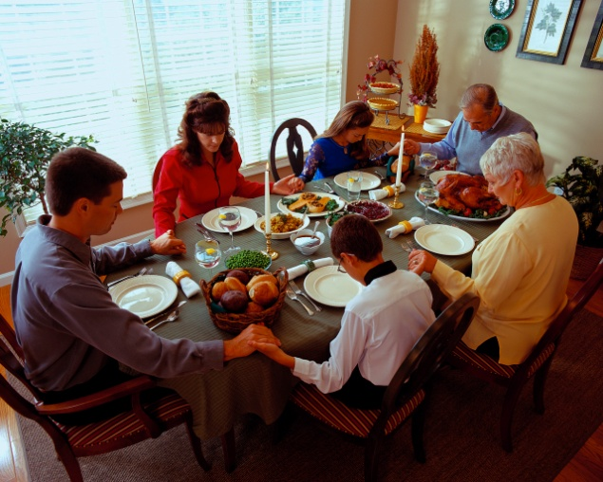

- Get perspective. When things go awry – and they will – stop to see if God’s hand is in it. He is able to bring good from any situation. It may end up better than your original plan. (I must take my own advice on this one because I am in the middle of a situation right now that is not turning out at all how I thought it would). I’m sure that traveling all the way to Bethlehem was not on the “to do” list of a woman who was close to giving birth. Any ladies who have had children can tell you of a surety that traveling rough roads on a donkey would not give you that cozy holiday feeling! But the Lord used an ungodly king and his plan to fulfill the ancient prophecies of the coming Savior. Never be surprised at who the message of God may come through.
- Just breathe. Take the time to breathe in the presence of God. If you have become too harried to sense His presence, STOP. He is all around you. He has promised to never leave you or forsake you. You can find him in the midst of all the noise and glitter if you seek for Him. “If you look for me in earnest, you will find me when you seek me. I will be found by you, says the Lord” Jeremiah 29:13-14. That promise is sure.

My greatest thanks and appreciation to all of you who have supported and encouraged me during this first year. May God’s blessings of peace and grace be to you all and may your Christmas truly be filled with the JOY of receiving His most precious gift.

